**8.Raspberry Pi platform -------** **servo_avoid_ultrasonic**

**1)****Preparation**

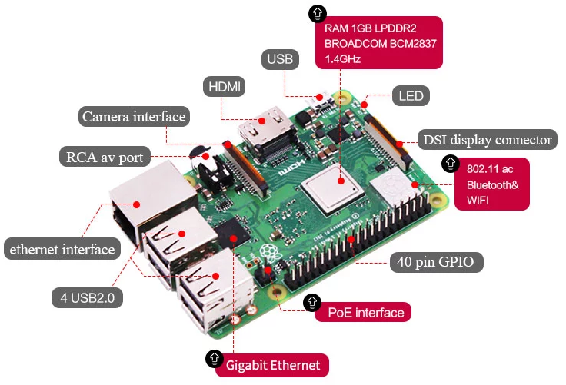

1-1 Raspberry Pi board

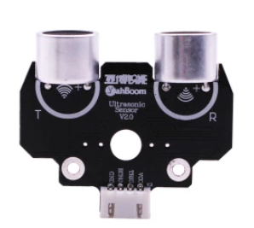 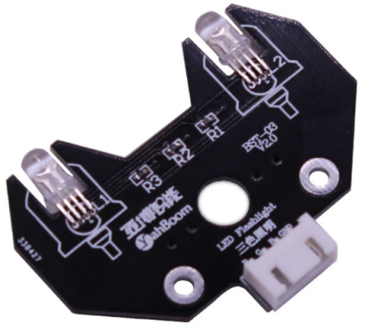

1-2 Ultrasonic module 1-3 RGB module



1-4 SG90 servo

**2)Purpose of Experimental**

After running the servo_avoid_ultrasonic executable in the Raspberry Pi system, you need to press the K2 to start the car, and the ultrasonic obstacle avoidance with servo function is started.

When the distance on the front is less than 30cm, the colorful light module is red, then servo turn to 0 degree, ranging and recording, servo turn to 180 degree, ranging and recording, servo turn to 90 degree, ranging and recording. And the robot car will compare the left and right distance to determine whether to avoid the obstacle to the left or right. When the distance in three directions is less than 30, the robot car will turn round.

**3)Principle of experimental**

The working principle of the servo: the control signal enters the signal modulation chip from the channel of the receiver to obtain the bias voltage of the DC. It has a reference circuit inside, which generates a reference signal with a period of 20ms and a width of 1.5ms. It will compares the DC bias voltage with the voltage of the potentiometer to obtain a voltage difference and output. The positive and negative of the voltage difference is outputted to the motor drive chip to determine the forward and reverse of the motor.

Servo rotation angle is by adjusting the duty ratios of PWM (pulse width modulation) signal. The standard PWM (pulse width modulation) signal has a fixed period of 20ms (50Hz). Theoretically, pulse width distribution should be between 1 ms to 2 ms, but in fact between pulse width can be 0.5 ms and 2.5 ms. Pulse width and the servo rotation angle 0°～180° corresponds, as shown below.

0.5ms-----------------0°

1.0ms-----------------45°

1.5ms-----------------90°

2.0ms-----------------135°

2.5ms-----------------180°

**4)Experimental Steps**

4-1 About the schematic

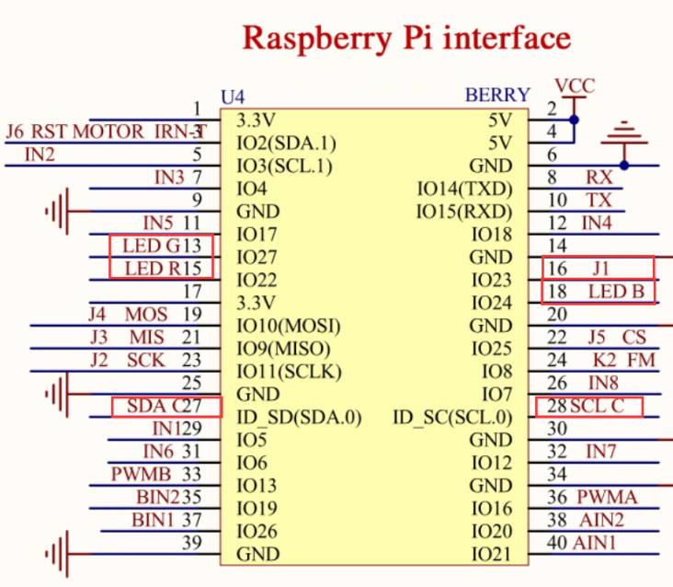

4-1 Raspberry Pi interface circuit diagram



4-2 ultrasonic interface

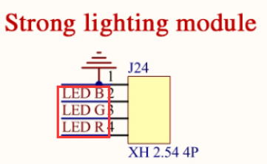 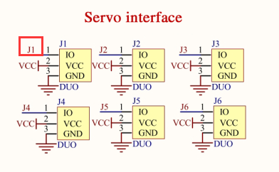

4-3 RGB module interface 4-4 Servo interface

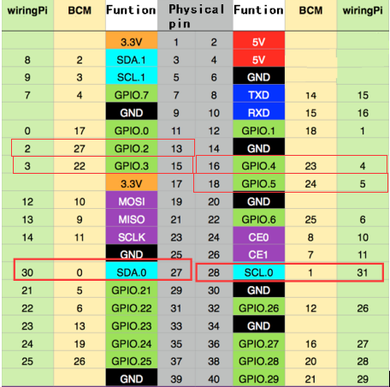

4-3 Raspberry Pi 40 pins comparison table

4-2 According to the circuit schematic:

Trig-----28(Physical pin)----- 31(wiringPi)

Echo-----27(Physical pin)----- 30(wiringPi)

(Note: We use the wiringPi library to write code.)

4-3 About the code

1. We need to compile this file in the Raspberry Pi system. (Note: we need to add -lwiringPi to the library file.)

We need to input:gcc servo_avoid_ultrasonic.c -o avoid_ultrasonic -lwiringPi

(2)We need to run the compiled executable file in the Raspberry Pi system.We need to input: ./servo_avoid_ultrasonic

As shown in the figure below.



(3)We can input: ctrl+c to stop this process, which mean is send a signal to the linux kernel to terminate the current process, but the state of the relevant pin is uncertain at this time, we also need to run a script to initialize all pins.

(Note:The initpin.sh script file is included in the SmartCar directory.)

You need to input:  chmod 777 initpin.sh

./initpin.sh

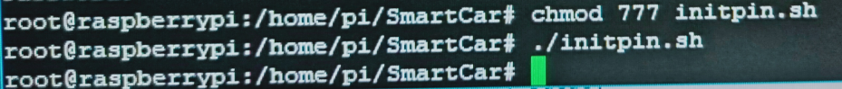

After completing the above steps, the experiment is over.